**OUTPUT:**

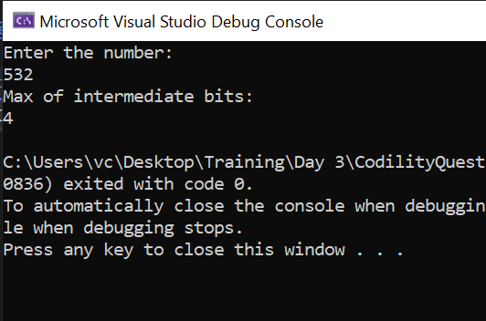

**CODE:**

namespace CodilityQuestions

{

internal class Program

{

static void Main(string[] args)

{

List<int> arr = [];

Console.WriteLine("Enter the number:");

int num1 = Convert.ToInt32(Console.ReadLine());

while (num1 > 0)

{

arr.Insert(0, num1%2);

num1 /= 2;

}

bool flag= false;

int count = 0,mc=0;

foreach (int item in arr)

{

if(item == 1)

{

if (flag)

{

if(count>mc)

{

mc = count;

}

count = 0;

}

flag = true;

}

else if (flag)

{

count++;

}

}

Console.WriteLine("Max of intermediate bits:");

Console.WriteLine(mc);

}

}

}